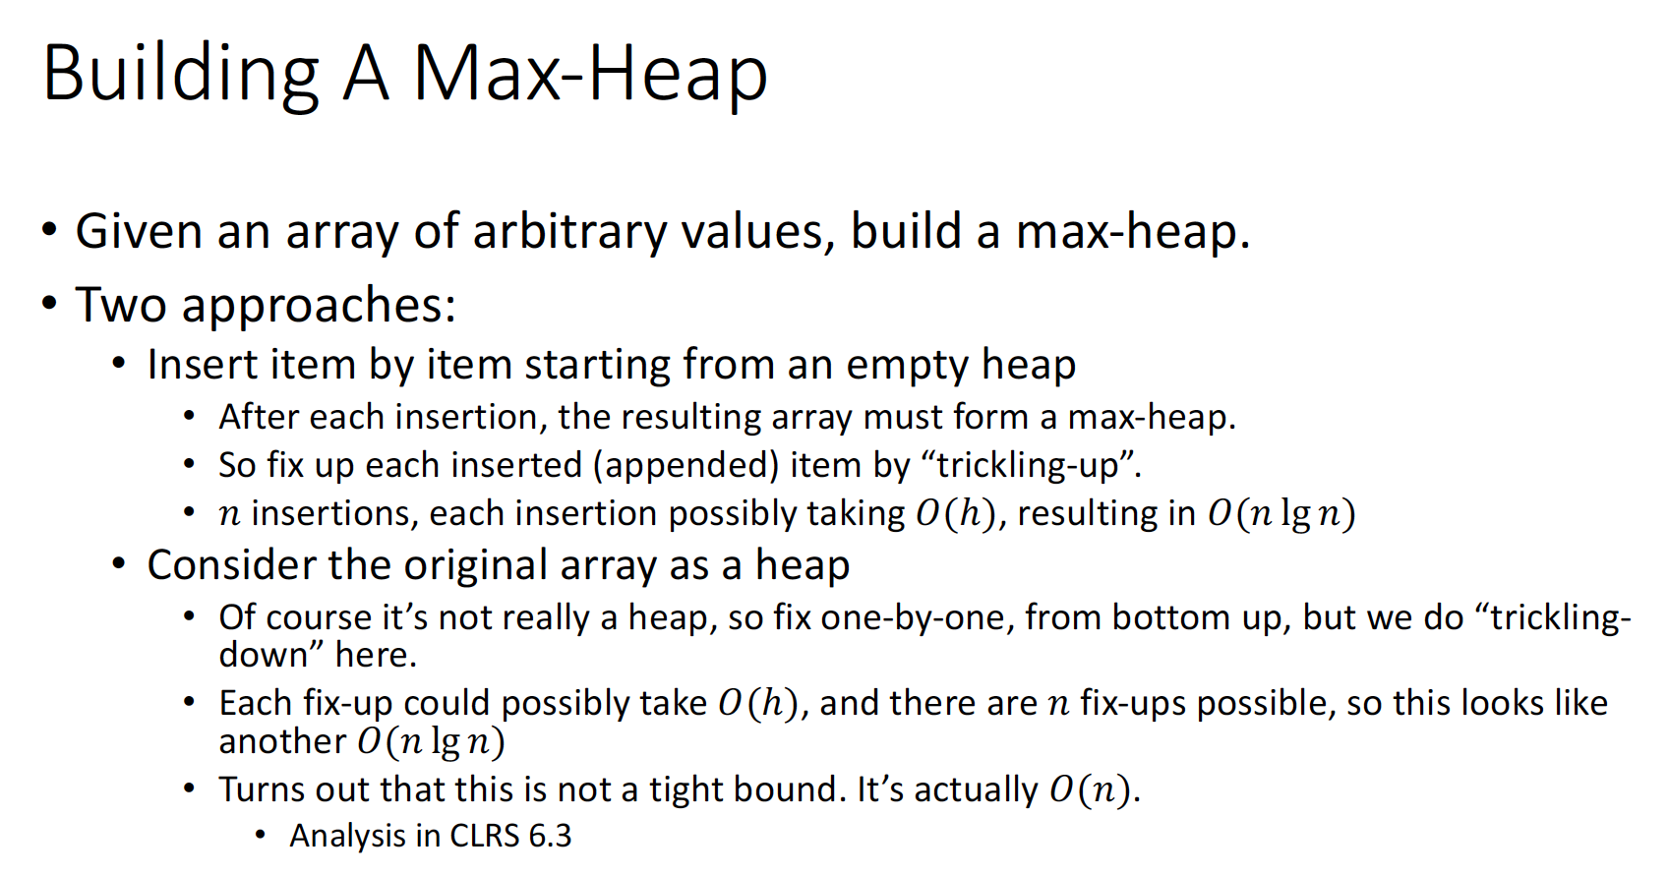

Why it is actually O(n)

Could you explain the sub-lemma and the last BP

If Z’s right subtree does not have the left most leaf, how to solve this problem?

Why the key 14 is into slot 9?

Do not understand the whole page

第四个bp不懂

My solution is try to find all the possible combinations of activities, and then try to find the maximum value of these combinations. The time complexity is O(n^2)

Still confused about the cut and paste technique!!!

2-2.3??

a **loop invariant** is a property of a [program](https://en.wikipedia.org/wiki/Computer_program) [loop](https://en.wikipedia.org/wiki/Control_flow#Loops) that is true before (and after) each iteration

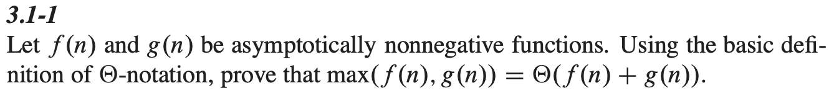

Do not understand this pic.

**Do not understand The substitution method for solving recurrences**

Time complexities of insert/delete/search algorithms on sorted/unsorted arrays/linked lists

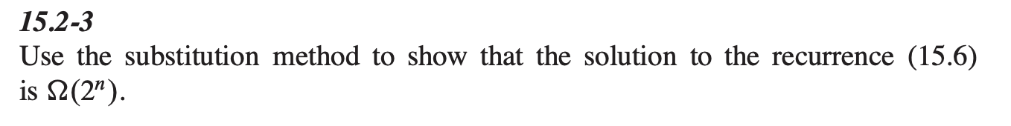

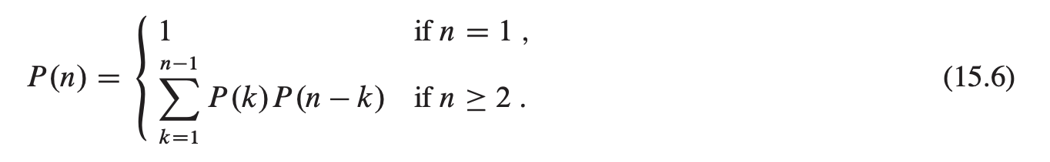

Do not understand the last BP?

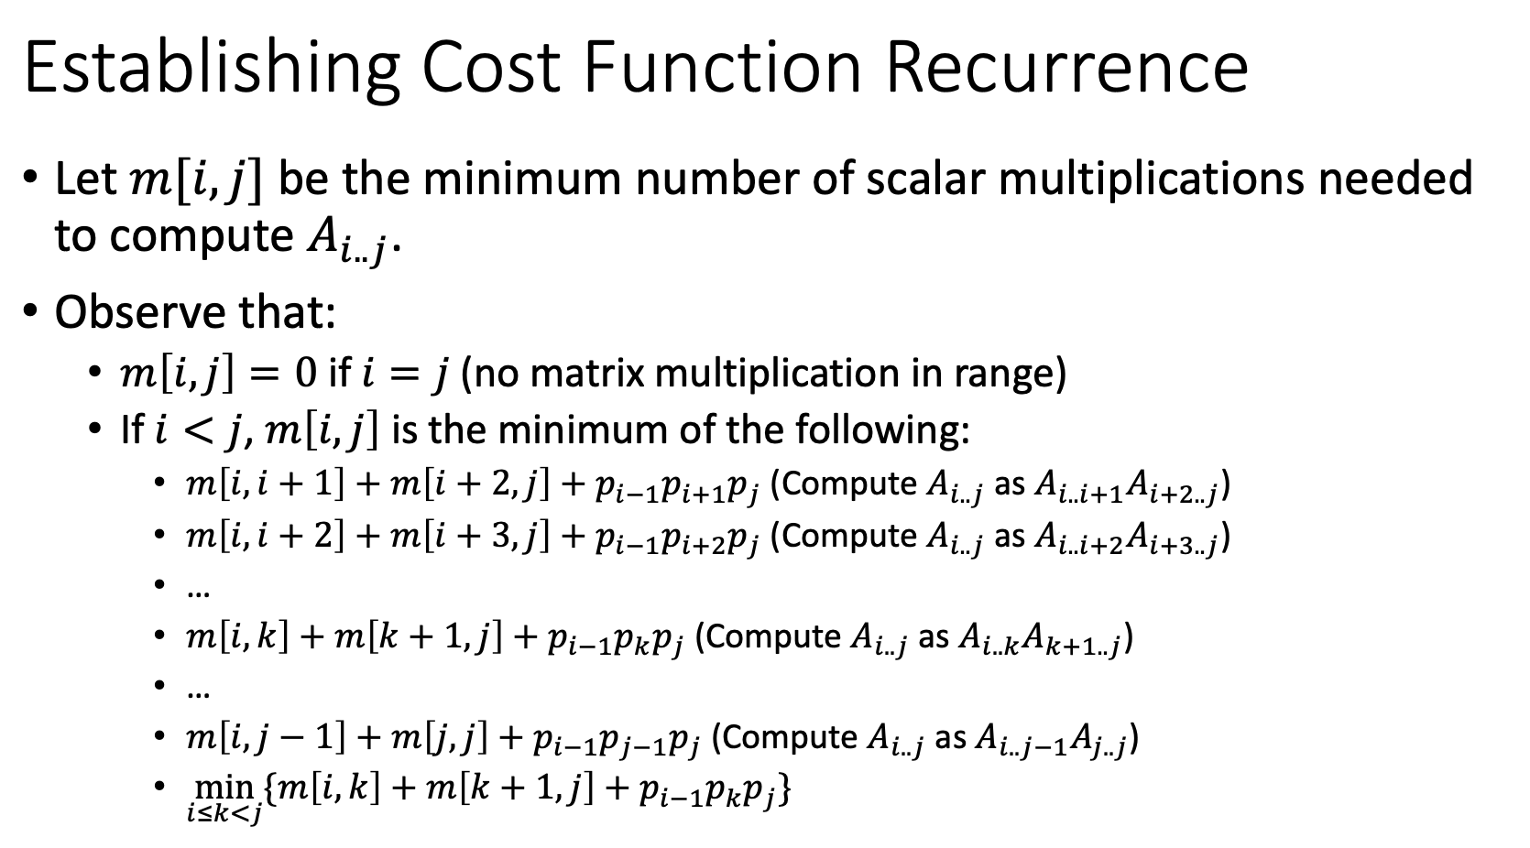

Do not understand second BP’s bp

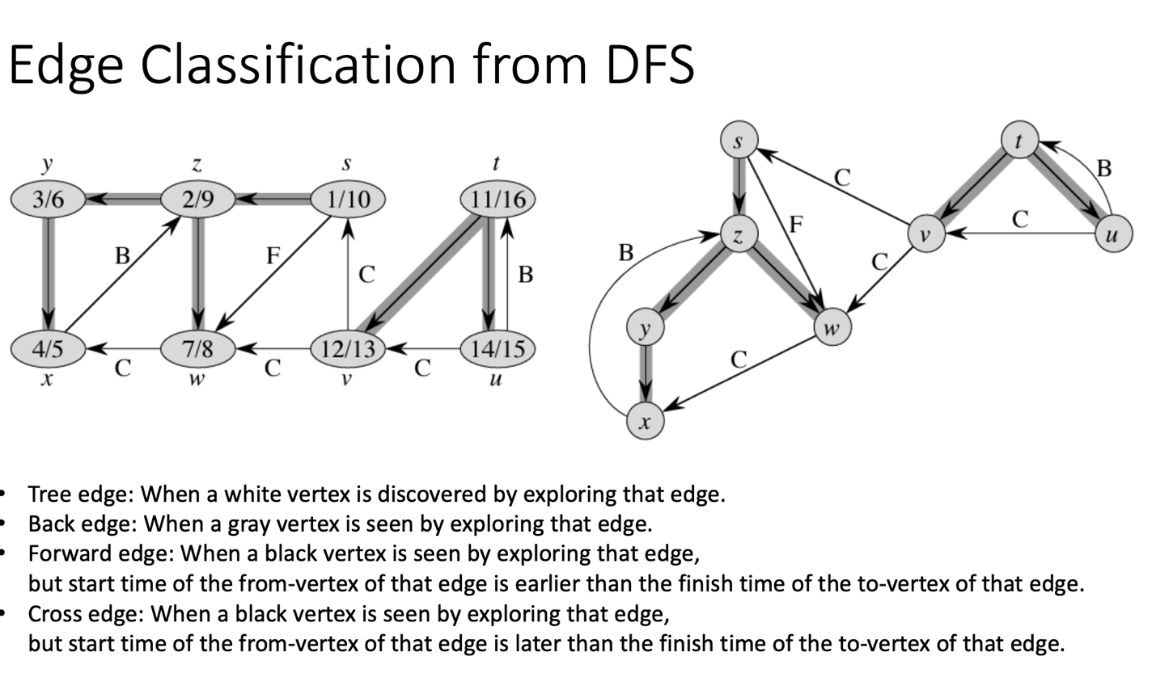

What is w/h

Could you explain the last 4 bp?

What is ‘find a cut that respects A’, what is ‘all edges crossing the cut’

Why O (1) for find-set

Why the running time of Kruskal algorithm is O (E*lgV)

Can you explain this code?

‘which will give yes or no’. can you explain this?

Could you explain this page to me

Can you explain this page

What is the overflow bucket

Why need to split 1 bucket into 2 buckets if new record is added.

Could you explain the first question in assignment 4

What is locality of reference in B+ tree

Can you explain this page?

Can you explain the time complexity of search in B+ tree